To: | Council
Date: | 13 February 2019
Report of: | Electoral Registration Officer
Title of Report: | Community Governance Review – Headington area

Summary and recommendations
Purpose of report: |  | To brief Council on the request to create a community council in the area covered by the 2017 Headington neighbourhood plan referendum.
Key decision: |  | Yes
Executive Board Member: |  | Councillor Susan Brown, Leader of the Council
Corporate Priority: |  | None
Policy Framework: |  | None
Recommendation(s):That the Council resolves to:
 | Agree the terms of reference for the community governance review for the Headington area.

Appendix
Appendix 1 | Terms of reference for the review

Introduction
- As Council will be aware a neighbourhood plan referendum (NPR) took place in May 2017. It covered all of Headington ward and parts of Barton and Sandhills, Headington Hill and Northway, Quarry and Risinghurst and Churchill wards.
The neighbourhood plan was approved: 86% in favour and 14% against.

Request for a community governance review (CGR)
- In October 2017 the neighbourhood forum made an application to the Council to carry out a community governance review with a view to setting up a new community council for the area covered by the neighbourhood plan. They were able to make this request under the Legislative Reform (Community Governance Reviews) Order 2015 (“the Order”) which introduced Section 80A to the Local Government and Public Involvement in Health Act 2007 (“the Act”). Section 80A of the Act provides that neighbourhood forums can, following a successful NPR, request a council to carry out a CGR without needing petition (as is usually the case). Parish councils can now style themselves as “community council” rather than a “parish council”. The Headington Neighbourhood Forum has requested that any new council be named “Headington Community Council”
- The CGR is governed by the provisions in the Local Government and Public Involvement in Health Act 2007. The Ministry of Housing, Communities and Local Government has issued detailed guidance, which can be found at https://www.gov.uk/government/publications/community-governance-reviews-guidance .
- Principal councils are given a wide discretion on how to carry out reviews and ultimately it is the Council’s decision whether a parish is created or not. The Council must consult widely and consider any responses in making its decision.
- It is proposed that a pamphlet will be sent to every household in the affected area, explaining the proposals and what setting up a community council might mean, using the existing parish councils in Oxford as examples. There will be various methods for residents and interested parties to submit comments. Other groups and organisations in the area will also be consulted and anyone with an interest will be allowed to comment.
- Terms of reference are attached at Appendix 1.
- The extent of the area under review is shown in the map:
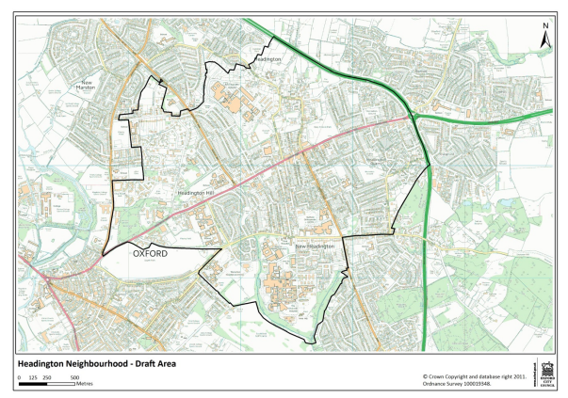

- An indicative timetable is shown below:
Stage | Timing | Function
Stage One | 13 February 2019 | Agreement by Council to the terms of reference
Stage Two | February 2019 | Drawing up the pamphlet
Stage Three | April-June 2019 | Distribution of pamphlet and an eight-week period for replies
Stage Four | July-August 2019 | Reviewing replies and preparing to report to Council
Stage Five | 7 October 2019 | Report to Council on consultation outcomes
Stage Six | April 2020 | (if approved) Creation of community council
Stage Seven | May 2020 | (if approved) First elections to the new council

Financial implications
- There are financial implications insofar as there will be a need for Finance to do significant preparatory work to enable the community council to be funded.
If a new council is created the City Council would set a precept for it this autumn, to provide for basic things like employing a clerk and provide a small budget. Any new community council would then decide its priorities and set an appropriate precept for 2021/22.
- The City Council would provide clerking services for the first few months of the new council’s existence, until the newly elected council can go through a recruitment process.
- Also, there is a cost to the review itself. These are mainly for printing and postage. The costs are estimated at £5000 and should be contained within electoral services budgets in 2018/19 and 2019/20.

Legal issues
- There are legal implications insofar as the Council must ensure that it makes its decision, whatever that might be, in accordance with the Local Government and Public Involvement in Health Act 2007 and associated regulations and guidance.

Report author | Martin John
Job title | Electoral Services Manager
Service area or department | Law and Governance
Telephone | 01865 252518
e-mail | mjohn@oxford.gov.uk

Background Papers: None

